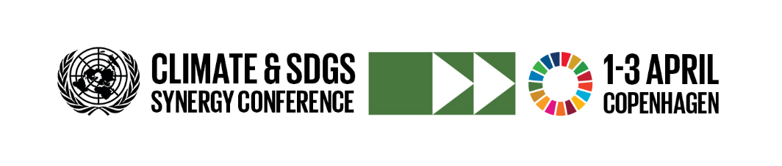
Session on Synergies in action (II): Promoting cross-sectoral integrated response for a just transition: Promoting prosperity”. 15:30 – 17:00 on 1 April.
BACKGROUND
A transition towards low-carbon and climate-resilient economies will impact societies and communities in several ways, with potentially positive and negative effects. While there is overwhelming evidence to suggest that ambition climate action can ultimately yield prosperity, it is crucial to ensure a just transition for all through integrated responses. The Paris Agreement on climate change recognize the need to address all the effects of climate change and policy responses to it, noting “the imperatives of a just transition of the workforce and the creation of decent work and quality jobs in accordance with nationally defined development priorities”.
A just transition to sustainability is about ensuring that the economic, environmental and social consequences of the transformation of economies and societies towards greater sustainability are managed in ways that maximize opportunities of decent work for all, reduce inequalities, promote social justice, and support industries, workers and communities negatively impacted.
To that effect, cross-sectoral integrated responses to climate change are essential. Cross-sectoral integrated responses imply that environmental policies are well coordinated with social and economic policies. Well-coordinated actions can be a driver for economic growth, job creation, and poverty eradication, allowing climate and social justice for all and promoting, protecting and fulfilling human rights for all including those most vulnerable to climate change. Inversely, failing to address social impacts from economic and industrial restructuring could contribute to job losses, social exclusion and disruption on a massive scale.
More specifically, important aspects can include i) mechanisms of inclusive social dialogue to forge strong social consensus to enable transformative change without major social and economic disruption, ii) Skills development, training and capacity building plans to enable smooth transitions in labour markets, transformation in enterprises, and adjustments in consumption and production systems; and iii) innovative social protection policies to strengthen climate adaptation strategies and protect groups and communities particularly vulnerable and likely to be negatively impacted by climate change and policies responses to it.

OBJECTIVE OF SESSION
This session will discuss ways to promote prosperity through national development plans, institutional structures and coordination mechanisms related to SDGs, NDCs and the Sendai framework.
Participants will examine the nature and scale of expected and ongoing structural transformations impacting economies, enterprises, workers and communities, with significant implications for inclusive growth, income distribution, poverty and social inclusion. They will discuss practical means to achieve a just transition for all and consider the global and national policy frameworks that countries can employ to pursue climate-resilient economies. The event will promote the idea of a common and “positive narrative” on just transition as corollary of ambition climate action, NOT a justification for low ambition.
KEY MESSAGES
- Climate change and the policy responses to it bring new challenges and opportunities for prosperity, social justice, human rights, jobs and livelihoods that must be addressed at all levels. Prosperity and a just transitions will not happen by default: they require careful planning, policies, funding, and social dialogue among all key actors to fully take advantage of the opportunities and minimise risks.
- The absence of dedicated social policies and measures for vulnerable groups, workers, enterprises and communities can cause economic and social disruption and trigger social/political resistance to change.
- The review of SGD8 and 13 at the 2019 High-level Political Forum must be taken as a unique opportunity to integrate policies and measures on just transition in nationally-determined contributions, and reporting on progress on SDG 8 and 13.
QUESTIONS FOR DISCUSSION
- What policies and initiatives are needed at the global and national levels to ensure a just transition for all?
- Which participatory processes are required in the implementation of climate commitments to secure rights for all actors to play their part?
- What successful experiences, policy and planning processes exist to draw upon for advancing ambitious climate action that leads to prosperity for all, leaving no one behind?

FORMAT OF SESSION
Opening: opening remarks and a brief outline of the overall context and objectives of the session.
Panel discussion: an interactive discussion composed of five panellists comprising leading experts (senior officials, practitioners, researchers).
Open Discussion: moderated discussions among panellists and participants.

Promoting prosperity | Partnerships and stakeholder action
Moderator: Mr. Moustapha Kamal Gueye, Coordinator, Green Jobs Programme, Enterprises Department, International Labour Organization (confirmed)
-Mr. Karma Sonam Tshosar, Deputy Permanent Representative, Permanent Mission of Bhutan to the UN (confirmed) | Governments can shape policies and values for prosperity and wellbeing of their people. What makes Bhutan unique in its approach to well-being and prosperity?
-Mr. Frank Rijsberman, Director-General, Global Green Growth Institute (TBC) | There is strong evidence that policies to address climate change can deliver economic growth and power other SDGs. What are prerequisites for such growth to be inclusive and beneficial to all?
- Mr. Shoaib Sarwar, Assistant Director, Ministry of Foreign Affairs, Pakistan (TBC) | Pakistan has taken innovative approaches to jobs creation and inclusion through innovative programmes such as the “tsunami project” to reduce the risk of natural disasters. What lessons can be drawn from such experience?
- Mr. Eco Matser, Global Coordinator for Climate Change, Energy and Development, HIVOS (confirmed) | The energy transition represents a central pillar of climate action. What approaches can enable a transition without major economic and social disruption?

Reading and reference documents
UN Environment Management Group - Nexus Dialogue Greening with Jobs: A Just Transition to Sustainability, 23 October 2018. Ten Key Messages – By UN EMG
Guidelines for a just transition towards environmentally sustainable economies and societies for all – By ILO
Climate change and the just transition: A guide for investor action – by LSE, Grantham institute et al.

