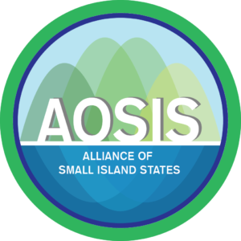
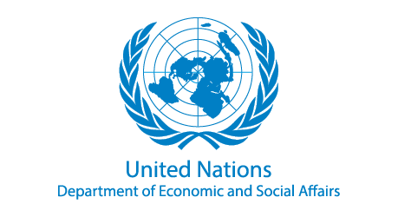

“The science is in: Ambitious Action will deliver a win-win for the Climate and Sustainable Development”

A SIDS organized Event in the 1st Global Conference on Synergies between the 2030 Agenda and the Paris Agreement Copenhagen, Denmark April 1-3, 2019.

Short description

This side event is co-hosted by UN-DESA and the Alliance of Small Islands States (AOSIS) in the margin of the 1st Global Conference on Synergies between the 2030 Agenda and the Paris Agreement, Copenhagen, April 1-3, 2019. It aims to outline the findings of the latest Intergovernmental Panel on Climate Change (IPCC) Report; make a case for aligning climate action and development action; and emphasize the urgent need for a system-wide response to this alignment – at the national, regional and global level.

Background/sketch

In its latest Special Report on the impacts of a global warming of 1.5ºC (SR1.5), the IPCC provides the most comprehensive scientific assessment to date on the inter-linkages between Paris Agreement-compatible climate action and Sustainable Development Goals, outlining co-benefits and opportunities as well as ways to overcome or minimize potential trade-offs. For example:

“1.5°C pathways have robust synergies particularly for the SDGs 3 (health), 7 (clean energy), 11 (cities and communities), 12 (responsible consumption and production) and 14 (oceans) (very high confidence).”

The report also identifies policy responses to address and minimize potential trade-offs between stringent climate action and some aspects of sustainable development and makes it very clear that a substantial increase in near term ambition is required to align sustainable development and climate targets.

In order to achieve the Paris Agreement goals, countries need to come forward with more ambitious new or updated NDCs by 2020. Opportunities arising from higher climate ambition and a more thorough integration with the SDGs requires more systematic attention.

For vulnerable developing countries, especially Small Island Developing States (SIDS) and the Least Developed Countries (LDCs), achieving the SDGs will also depend on efficient and effective deployment of climate finance and improved capacity to access finance opportunities. The ongoing Financing for Development process, often treated as separate, can reinforce the Paris goals and facilitate the unlocking of and tapping into a wider range of sources and means of implementation, while drawing on the synergies between climate action and the SDGs.

This event will look at the rationale for aligning more ambitious climate action and development action with a view to shifting the global policy rhetoric to focus on the complementarity between climate action and development gains. It will address the need for an all of system response to this alignment – at the national, regional and global level, including with respect to identifying the necessary means of implementation.

More specifically, the event will respond to four questions:

- what does the latest IPCC science say about interlinkage between climate change and sustainable development? What are the key take away of the SR1.5?
- How can the opportunity for new and updated more ambitious NDCs by 2020 be used as an opportunity to better align SDG and climate action?
- What steps can national policy makers take to leverage synergy opportunities drawing on good practices and lessons learned since the adoption of the 2030 Agenda and the Paris Agreement?
- What will need to be addressed at the international level to stimulate and facilitate these actions including through mobilization and provision of the necessary means of implementation?

Objectives of the event

The Event aims to:

- Outline what the IPCC says about synergies between limiting warming to 1.5ºC and achieving specific SDGs, and discuss how to minimise potential trade-offs;
- Explore what aligning climate action and sustainable development agenda means for policy makers/implications for the next round of Nationally Determined Contributions (NDCs), long-term low GHG emission development strategies, and national development plans;
- Discuss ways in which climate finance and financing for development can complement each other.

Targeted Audience

Targeted audience of the Event includes all participants of the Climate and SDG Synergy Conference: policymakers in the areas of climate change and SDGs, diplomats, NGOs, academia.

Presentations & Presenters

- Climate action to limit warming to 1.5°C as a key SDG enabler: latest from the IPCC
(Dr. Michiel Schaeffer, Director/Senior Scientist, Climate Analytics)

- Joining the dots: how the next round of NDCs can harvest synergies between climate action and SDGs
Presenter -(TBC)

- Exploring the cross section of climate finance and development finance: how to re-envision the Financing for Development process as a platform to a new global policy rhetoric of alignment and complementarity?
Presenter – (TBC)
- Panel discussion with (2) vulnerable country representatives: “Financing for climate AND development - tapping into a wider range of sources to enable SIDS reach climate and development goals”.
Presenter 1 (TBC)
Presenter 2(TBC)

Moderator

Carlos Fuller, AOSIS Lead Negotiator on Climate Change

Contact Person:

Ms. Anya Thomas
Economic Officer - SIDS Unit
Division for Sustainable Development Goal (DSDG)
UN-DESA
thomasa@un.org

A SIDS organized Event in the 1st Global Conference on Synergies between the 2030 Agenda and the Paris Agreement Copenhagen, Denmark April 1-3, 2019.

DRAFT PROGRAMME
OPENING REMARKS
12:00 - 12:10 | Mr. LIU Zhenmin, Under Secretary-General UNDESA (TBC)  H.E. Ms. Louis Young, Chair of AOSIS, Permanent Representative of Belize to the UN (TBC)
MAIN PRESENTATIONS
12:10 – 12:20 | Climate action to limit warming to 1.5°C as a key SDG enabler: latest from the IPCC  - Dr. Michiel Schaeffer, Director/Senior Scientist, Climate Analytics
12:20 -12:30 | Joining the dots: how the next round of NDCs can harvest synergies  between climate action and SDGs  [SIDS Case-Study]  - TBC
Exploring the cross section of climate and development finance
12:30 -12:45 | Presentation on challenges that SIDS face formulating ambitious climate policies and aligning them with development priorities  - H.E. Mrs. Yvonne Sharman Hyde, Chief Executive Officer of the Ministry of Economic Development of Belize
Presentation on potential opportunities for the Financing for Development process to contribute to a new global rhetoric on alignment and complementarity.
- TBC
12:45 – 1:20 | Moderated Discussion
CLOSING REMARKS
1:20 -1:30 | Summary – Moderator  Remarks  - UNDESA  - Belize

END

