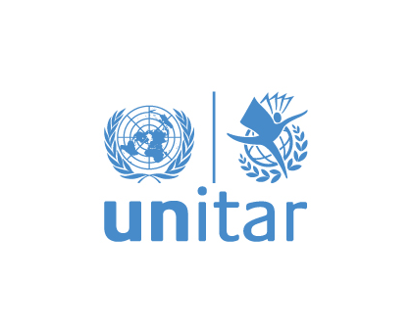
UN High-level Political Forum (HLPF) on Sustainable Development 2020
Under the auspices of ECOSOC
SDG Learning and Training 2020
“Accelerating action through digital technologies: strengthening digital skills and capacities for human wellbeing”

Virtual meeting organized by ITU and UNITAR
Wednesday, 8 July 2020, 09:00 – 10:30 a.m. EDT

Brief description of the session
Digital technologies are key accelerators for achievement of sustainable development. The availability of technology and the use of digital tools contributes to progress being made on each of the 17 SDGs. The decade of action will also be a decade of accelerated technological progress, characterized by – among others – the rapid growth in AI, big data analytics, Internet of Things, and robotics. The COVID-19 pandemic dramatically underlined the vital importance of meaningful connectivity to people’s livelihoods, employment, health and well-being, education, and social participation. In the developing world, millions of students who were out of school during the pandemic did not have access to formal education due to the lack of connectivity, skills and capacity to use digital tools. In addition, thousands of job vacancies go unfilled each year due to the lack of a digitally skilled workforce. This puts Governments, educational institutions, and industry under pressure to react and implement policies and programmes that increase the level of digital competence in countries. Core to developing such policies and programmes is the identification of national skills supply, skills demand and skills gaps, which is required to develop targeted and effective action.
This session will highlight the importance of digital skills and capacity for achievement of the SDGs. It will present methodologies to carry out national digital skills assessments that will inform Government and other stakeholders. The ITU Digital Skills Assessment Guidebook 2020 offers step-by-step guidelines on how to undertake such assessments, which methodologies and approaches to apply, and which data sources to be used. The One UN Climate Change Learning Partnership (UN CC:Learn) is an example of a successful digital tool to implement systematic, recurrent and results-oriented climate change online learning linked to various SDGs.

Key objectives
- To illustrate the link between digital knowledge/literacy and skills on the one hand, and acceleration of action on the other hand, for achievement of sustainable development
- To showcase and explain how digital skills assessments can be implemented at the national level
- To provide examples of successful digital skills assessments and strategies
- To provide examples on how capacity development in digital technologies can contribute to digital transformation and countries’ abilities to achieve the SDGs

PROGRAMME

09:00 - 09:15 a.m. Introduction and opening remarks
- Doreen Bogdan-Martin, Director, Telecommunication Development Bureau, ITU
- Einar Bjorgo, Director, Division for Satellite Applications and Applied Research, UNITAR
Moderator: Ursula Wynhoven, ITU Representative to the United Nations, New York
09:15 – 10:00 a.m. Accelerating action through strengthening digital capacities and skills
Short presentations by panelists on the key topics of the session and addressing questions such as:
Why are digital capacities and skills critical to development? How can countries assess national digital skills needs to better target policies? What does the future job market look like and how can we ensure young people have the required digital skills demanded by the industry? What are successful examples of policies, programmes and platforms to strengthen digital skills at national level?
- Susan Teltscher, Head, Capacity and Digital Skills Development, ITU
- Stacey Wedlake, Research Analyst and Coordinator, Technology & Social Change Group (TASCHA), University of Washington, United States
- Angus Mackay, Director, Division for Planet, UNITAR
- Abraham Kofi Asante, CEO, Ghana Investment Fund for Electronic Communications (GIFEC)

10:00 – 10:30 p.m. Discussion, wrap up and closing

