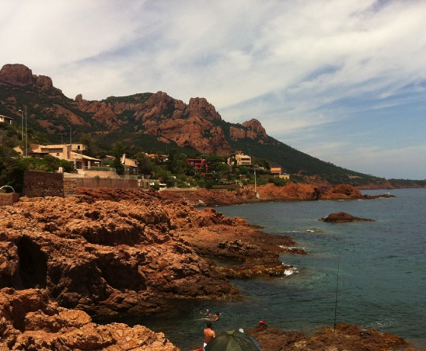
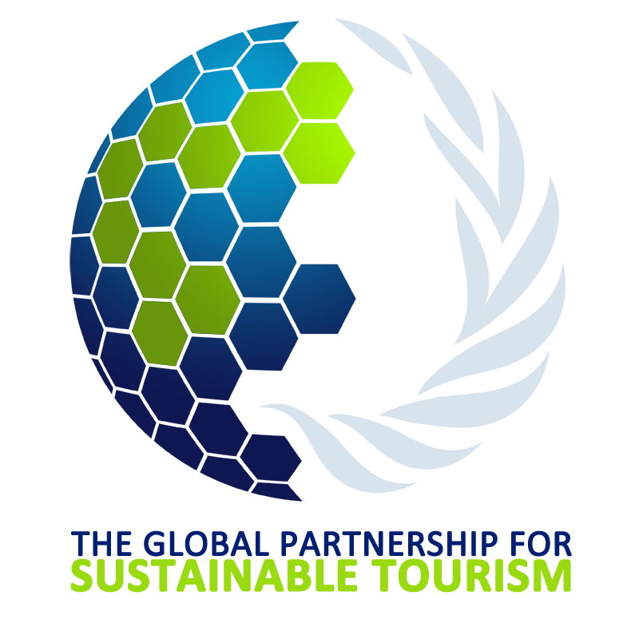

The Global Partnership for Sustainable Tourism
Summary of Activities
2011 – 2015
Draft
Table of Contents

From Start up to Transition… 3
The Chair’s Perspective 5
Remarks from UNEP 5
Remarks from UNWTO… 7
Summary of Activities, 2011 – 2015 8
Remarks from Partners… 16

From Start up to Transition…
The transition of the Global Partnership for Sustainable Tourism to the Programme on Sustainable Tourism of the 10-Year Framework of Programmes on Sustainable Consumption and Production (10YFP) has been anticipated since the conclusion of the work of the International Task Force on the Sustainable Development of Tourism (ITF-STD) in 2010.
It was at the UN World Summit on Sustainable Development held in Johannesburg, South Africa in 2002, where the call was made for governments to develop a “ten year framework of programmes on sustainable consumption and production” (10YFP). In 2003 the 1st International Expert Meeting on the 10YFP was convened in Marrakech, Kingdom of Morocco, coordinated by UNEP and UNDESA as a collective, multi-stakeholder effort to develop the framework. This was just one of six other task force groups. The Government of France chaired the ITF-STD from 2006-2009, which involved multi-stakeholder participants from 18 developed and developing countries, 9 international organizations, 7 NGOs and 7 international industry associations, collaborating on sustainable tourism framework priorities. The objectives were to encourage the development of tools, projects and good practice that foster sustainable tourism development. The Policy Recommendations of the ITF-STD was published in 2009.
Since 2011, as the successor to the former Marrakech ITF-STD, the Global Partnership for Sustainable Tourism was launched in order to build on and continue the work and momentum of the ITF-STD in collaboration with governments, private sector and civil society partners. The Global Partnership for Sustainable Tourism has been implementing the Policy Recommendations through its annual work programmes, its 80+ partners across 7 regions, led by its 11-member Steering Committee (www.gpstourism.org).
The 10YFP Programme on Sustainable Tourism now led by the World Tourism Organization (UNWTO) with co-leads, the governments of France, Korea and Morocco, will build upon the work of the Global Partnership, and serve those partners who have already signed onto the 10YFP.
The inter-governmental mandate of the 10YFP established at the RIO+20 Conference in Brazil in June 2012 provides the global framework that will deliver support at regional and national levels for the shift to SCP patterns. The Programme on Sustainable Tourism (including ecotourism) is one of six 10YFP programmes. SCP and the 10YFP have increasingly become a focus of the international development agenda, notably in the Open Working Group on the Sustainable Development Goals. The 10YFP and its programmes may well prove to be an implementation mechanism of the future post-2015 development agenda, which will be established in the latter half of 2015. All partners should therefore not lose the opportunity to participate in the 10YFP Programme on Sustainable Tourism, that has already increased the possibility of tourism sector funding.
This summary highlights the results accomplished of the Global Partnership over the past 4 years. The period was short but a lot was achieved. It also features the testimony of selected partners whose work we are proud to highlight as examples of sustainability in action. We hope that readers would be inspired to continue developing partnerships globally and to jointly pursue the cause for a more sustainable tourism industry.

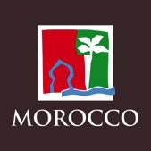
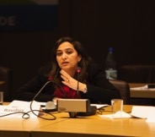
The Chair’s Perspective
Mme. Nada Roudies
Secrétaire Générale, Ministère du Tourisme, Royaume du Maroc
As Steering Committee Chair of the Global Partnership for Sustainable Tourism, it has been my task over the past 2 years, to preside over the progress to and now final stage of transition to the 10YFP Programme on Sustainable Tourism!
My perspective is as one involved from the early days of the 1st international expert meeting of the Marrakech Process hosted by my government, the Kingdom of Morocco, that began global deliberations on sustainable tourism as part of the International Task Force for the Sustainable Development of Tourism (ITF-STD). The Kingdom of Morocco through the Ministry of Tourism has been part of this 7-year process (2003-2009). Since then, our unflagging commitment has continued with our involvement in the Global Partnership for Sustainable Tourism (2011-2015) and the Programme on Sustainable Tourism of the 10YFP, launched 5 November 2014 at WTM in London, U.K. The Kingdom of Morocco joined with the governments of France and Korea and the UN World Tourism Organization to lead the global 10YFP Programme on Sustainable Tourism. As Morocco pursues its tourism development strategy, tourism is considered s an important lever for social and economic development. Growth of the sector is essential for its viability, but is also matched by our sustainability goals, which are at the core of our strategy.
The Global Partnership for Sustainable Tourism took on the mantle of coordinating and transmitting the message and call for sustainability in tourism development to partners and countries, whilst also investing in the development of projects and related tools. Serving as Steering Committee Chair since 2013 and along with other colleagues, we have had the pleasure of guiding the development of the sustainable tourism project screening criteria to embed sustainability aspects into project design and implementation, advancing the understanding and application of sustainability principles through specialized workshops and research and at our annual symposia, and keeping sustainability on the agenda through our participation at inter-governmental meetings and events.
Over the years, we learned of the importance of leadership – from individuals and institutions in the public and private sectors and civil society groups. Leaders need to articulate the strategy, motivate and assemble talent and partners to implement the plan. Being a good and conscientious steward of our national patrimony is being a good leader and this benefits our citizens and communities, and the visitors we welcome to our shores.
We have learned that the complex challenges must be matched with diverse and integrated approaches. We are strongest when everyone contributes to the mission. With their collective wisdom, experiences, creativity, innovation, resources and ideas, partners working together united around a vision will overcome the complex challenges at every destination.
Finally, results take time to unfold. We therefore need to be patient, yet focused and deliberate. As we look to the future and the 10YFP Programme on Sustainable Tourism, we remain expectant, committed to excellence and united in partnership. On behalf of my Steering Committee colleagues, I thank all partners for their work and for sharing their resources and ideas with the Global Partnership. I hope to continue working with you in the 10YFP and to welcome new partners and ideas to the continuing global effort on sustainable tourism.

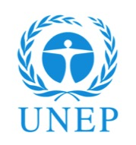
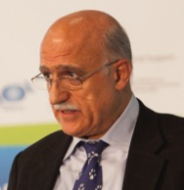
Remarks from UNEP…
The United Nations Environment Programme

The year 2014 may be described as one of significant importance for global multi-stakeholder processes.
Arab Hoballah, Chief Sustainable Cities, Lifestyles & Industry
In the inter-governmental Open Working Group discussions for the post-2015 Sustainable Development Goals (SDGs), sustainable consumption and production is an identified goal and now firmly situated in the international agenda. Countries appear to be on track for a global climate agreement at COP21 in Paris in 2015.

The 10YFP Secretariat has now launched 4 of its 6 programmes, the Programme on Sustainable Tourism, among them. This could not have been accomplished without UNEP’s ability to achieve significant impact through partnerships, which are integral to the organization’s strategy to place environment and sustainable development at the heart of everything we do. All of these international, inter-governmental processes are about people working together achieving collective impact: shared risks, shared reward.

We are faced with challenging environmental trends. UNEP reports that population growth quadrupled to 7 billion people with projections of 10 billion by 2100. Urban areas house half the world’s population, use two-thirds of global energy and produce 70% of global carbon emissions. Rising resource use is a factor in emerging and developing countries. Global economic output has increased 20-fold over the last 100 years and will continue to increase throughout this century. The scale, spread and rate of change of global drivers are without precedent and are pushing environmental systems to destabilizing limits. The tourism sector’s consumption of energy is sizable, growing and still largely dependent on fossil fuels. Tourism travel is increasing and energy-intensive contributing 5% to global GHG emissions (40% from aviation, 32% from cars, 1.5% from cruise ships). Another 21% of the sector’s emissions come from tourist accommodations and mostly for heating and air- conditioning. Clearly, the work has just begun. More needs to be done.

At the core of the Marrakech Task Forces and the Global Partnership for Sustainable Tourism was a small group of committed partners led by UNEP, working diligently to keep sustainable tourism on the global agenda. This has culminated in the 10YFP Programme on Sustainable Tourism with its inter-governmental mandate. Successful implementation of this Programme to achieve sustainable development as an ultimate goal is the next step. It has to apply relevant and available tools, institute sound governance structures and enhance the capacity of partners to respond. This was exactly the mission of the Global Partnership for Sustainable Tourism and what it has delivered over the years and what will continue to inspire and catalyze us to further action in facing the challenges ahead. Addressing many of them will not be easy, but with the spirit of cooperation, openness, fairness and respect for all views, I am confident we can achieve our collective ambitions.

Remarks from UNWTO…
Dr. Dirk Glaesser Director - Sustainable Development of Tourism
The World Tourism Organization
2014 was marked by the launch of the Programme on Sustainable Tourism of the 10-Year Framework of Programmes on Sustainable Consumption and Production Patterns (10YFP STP). It is one of the initial programmes of the 10YFP, the global framework of action aimed to enhance international cooperation to accelerate the shift towards sustainable consumption and production.
UNWTO is honoured to be leading this new initiative, which strives to achieve major shifts in tourism policies and stimulate greater sustainability within the tourism supply chain, together with the Governments of France, Republic of Korea and the Kingdom of Morocco, and with the critical support of UNEP. The initiative supports cooperation between stakeholders for the development and implementation of innovations and good practices in resource efficient and low-carbon tourism planning, reducing the loss of biodiversity, conserving ecosystems, preserving cultural heritage, alleviating poverty and improving sustainable livelihoods. The recent integration of the Global Partnership for Sustainable Tourism into the structure of this Programme is an important step which will enable it to build on the work carried out for the development of partnerships based on sustainable tourism principles, sharing knowledge and experiences and implementing innovative and transformative projects for the sector.
In 2014 UNWTO was involved in a number of global fora and initiatives focusing on maximizing the contribution that tourism makes to the main pillars of sustainable development - economic, environmental, cultural and social. In support of the global efforts against wildlife poaching on the African continent, UNWTO has developed a Briefing Paper on the economic value of wildlife watching tourism, which includes data based on surveys of UNWTO with Tour Operators and African Governmental Institutions.
2014 has also seen the adoption by the United Nations General Assembly of a milestone Resolution entitled “Promotion of sustainable tourism, including ecotourism, for poverty eradication and environment protection”, which builds on a report prepared by UNWTO. This Resolution, which was adopted by consensus and sponsored by an impressive number of 107 Member States, places sustainable tourism firmly on the UN post-2015 agenda, as it requests UNWTO and other United Nations agencies to develop “…recommendations on ways and means to promote sustainable tourism, including ecotourism, as a tool for fighting poverty and promoting sustainable development…" to be submitted to the seventy-first session of the UN General Assembly in 2016.
We are confident that the integration of the GPST into the structure of the 10YFP Sustainable Tourism Programme will bring to the latter a network of committed members and partners as well as the remarkable work of the GPST on the development of capacity building tools together with its expertise on policy and project support. This integration will certainly help the 10YFP Programme on Sustainable Tourism to maximize efforts to accelerate the shift towards sustainable consumption patterns, along and across the value chains and will advance global sustainable development by harnessing the power of one billion tourists who travel the world every year as a force for good.

Summary of Activities, 2011 – 2015
- Making a difference at national level
10 countries
Sustainable tourism policy advice included technical assistance and capacity building provided to governments in support of their national and regional initiatives to transform tourism

Advice included:
- Fostering multi-stakeholder dialogue and consultation on sustainable tourism;
- Supporting Green Economy sectoral assessments that identify key opportunities and options for a green economy transition at country level for tourism;
- Assisting countries in creating Indicators and Measurement Frameworks;
- Enhancing local knowledge and Building capacity;
- Mainstreaming SCP into national development strategies and tourism strategies;
- Forging partnerships and alliances with national, regional and global institutions.
Mainstreaming Sustainable Tourism, Train-the-Trainer Workshops: designed to raise awareness of the importance of pursuing more balanced tourism development and growth within the economic, social/cultural and environmental pillars and to promote effective project monitoring and measurement of success.
440 trained
Serbia, 2012  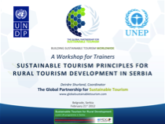 | Albania, 2012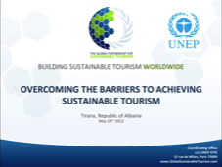 | Brazil 2013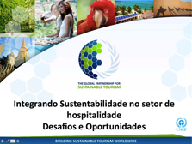
South Africa, 2013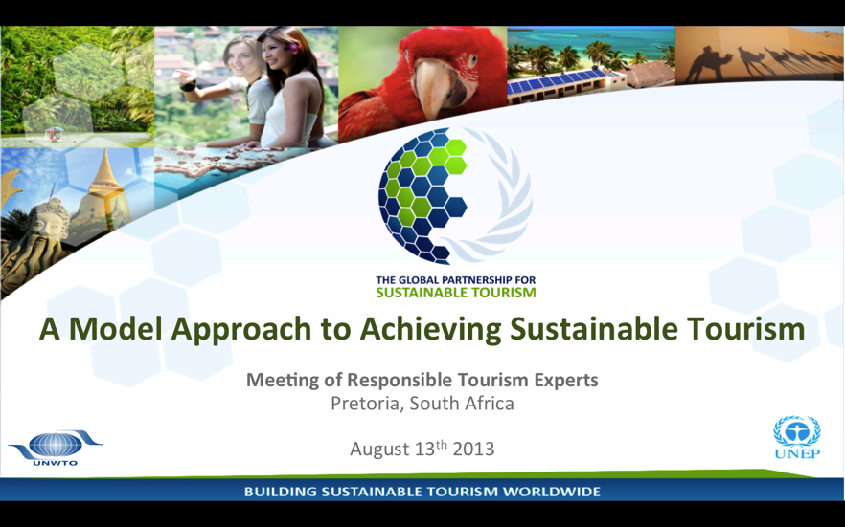 | Sri Lanka, 2014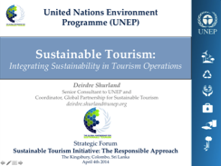 | Cape Verde, 2014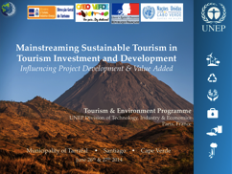

- Support at regional levels: sustainable tourism priorities research & project development
Region | Situation Analysis | Regional Flagship Project Concept
Caribbean  Fr  Sp  En  Partners:  Caribbean Tourism Organization (CTO)  Organization of Eastern Caribbean States (OECS) | 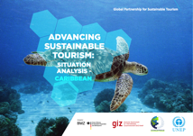 | Low-Carbon, Energy Resource & Efficiency for Modernizing Caribbean Tourism Economies – Pilot Project  Countries:  The Bahamas, Barbados, Jamaica, St. Lucia, St. Kitts & Nevis
Asia & the Pacific  En  Fr  Sp  Partners:  Republic of Korea  UNEP Regional Office for Asia & the Pacific (ROAP)  Pacific-Asia Travel Association (PATA) | 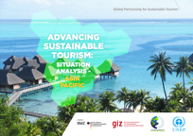 | Network of Sustainable Tourism  Countries:  Philippines, Thailand, Bhutan, Myanmmar, Korea, Indonesia, Maldives, India, Cambodia, Nepal
Southern Africa  En  Fr  Sp  Partners:  Regional Tourism Organization for Southern Africa (RETOSA)  Fair Trade Tourism (FTT)  Secretariat of the Convention for Biological Diversity (SCBD)  UNEP Regional Office for Africa (ROA) | 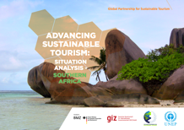 | Catalyzing Actions for Biodiversity Conservation in the Southern Africa Region  Countries:  Botswana, Mauritius, Mozambique, Namibia, South Africa, Tanzania
- Advising at the Global Level

Date | Key Global Event | Intervention
June 2012 | RIO+20 Conference on Sustainable Development, Rio de Janeiro Brazil | Contributions to and lobbying for decisions on sustainable tourism
September 2014 | 3rd UN International Conference on Small Island Developing States (SIDS), Apia, Samoa | Contributions to and lobbying for decisions on sustainable tourism
October 2014 | - Business & Biodiversity Forum: Tourism and Biodiversity Side Event, CBD 12th Conference of Parties (COP), Pyeongchang, Republic of Korea  - Revisions to the CBD Guidelines on Biodiversity and Tourism Development | 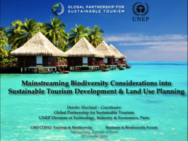
November 2014 | World Travel Market, London, U.K. | Launch of the 10YP Programme on Sustainable Tourism in collaboration with UNWTO
January 2015 | Implementation Meeting on Decision 5 of the XIX Meeting of the Forum of Ministers of Environment for Latin America & the Caribbean; UNEP Regional Office for Latin America & the Caribbean (ROLAC) | Caribbean tourism working group session, harmonizing regional priorities for action for Caribbean SIDS, for the Forum of LAC ministers of environment, the Samoa Pathway, and sustainable consumption & production

- Networking Events & Partners

- Sustainable Tourism Project Screening & Evaluation Tool
The sustainable tourism project screening criteria were developed as the core business tool of the Global Partnership for Sustainable Tourism. Its overall goal and purpose is to guide the design, implementation and outcomes of sustainable tourism projects implemented at destinations, along 7 thematic lines. These are also the thematic priorities of the Global Partnership: 1) Effective Policy Frameworks and Good Governance; 2) Climate Change Adaptation and Mitigation; 3) Protection of the Environment and Biodiversity; 4) Poverty Alleviation; 5) Preservation of Cultural and Natural Heritage; 6) Sustainable Management Practices by the Private Sector; and 7) Sustainable Financing and Investment.
More than 40 international experts reviewed the criteria. They were also presented to a donor’s and technical expert meeting in January 2012 in Washington D.C., USA.
Project screening documents include:
- An application form with template forms for submitting the curricula vitae of key project staff, a logframe of ‘SMART’ project results and outcome indicators and measures, and a project budget.
- The Guidelines or information document for proponents preparing and submitting the application form. Contents include guidance for interpreting and selecting from among the 7 priority themes in the screening and assessment phases. The Guidelines outline the requirements and steps of the screening and assessment phases and the use and application of the prescribed forms and templates.
- The project screening questionnaire comprising a screening form for each of the 7 priority themes, organized for each theme.
6
Screened projects
The Coordinating Office of the Global Partnership provided technical support to proponents on the use of the project application package through interactive teleconferences. The screened projects are listed below.
Submitted by | Project Title
The Travel Foundation, U.K. | Guaranteed Gambian: Creating Linkages between Crafts Producers and the Tourism Sector
Fair Trade Tourism, South Africa | Building Mechanisms for Climate Change Mitigation in South African Tourism
The Regional Tourism Organization of Southern Africa (RETOSA) | Regional Sustainable/Green Tourism Strategy and Framework for Southern Africa
JLAG, U.K. | Training for European Sustainable Tourism
Les Villages Nature de Val d’Europe S.A.S., France | Villages Nature: Un jardin d’harmonie
Rainforest Alliance, Costa Rica | Sustainable livelihoods and biodiversity conservation through sustainable tourism in the Amazonian region of Ecuador and Peru

Sustainable Tourism Project Screening Criteria | Importance Weight  (3 = Highest or compulsory)
1.0 EFFECTIVE POLICY & GOOD GOVERNANCE
1.1 The project promotes policies that reflect UN ethics and codes, agreements and conventions, and links tourism to sustainable initiatives | 1
1.2 The project promotes policies that define a clear vision for tourism based on carrying capacity, that preserve destination values, indigenous cultures and rights, and maximize employment and use of local products and services | 3
1.3 The project embraces policies that emphasize the importance of leadership, shared purpose and benefits for sustainable tourism | 1
1.4 The project aims to integrate sustainable consumption and production approaches into tourism policy as well as into national and regional development plans | 1
1.5 The project promotes policies and plans that integrate tourism investment, planning, management and operations with sustainable practices | 2
1.6 The project promotes policy development that stresses transparent, participatory and cross-sectoral multi-stakeholder involvement | 3
1.7 The project prioritizes policies for sharing of data, knowledge and learning at the destination | 2
1.8 The project promotes policies that encourage clear and verifiable communication of information on sustainability choices | 1
2.0 CLIMATE CHANGE ADAPTATION & MITIGATION
2.1 The project contributes to low carbon development and climate adaptation plans | 3
2.2 The project promotes institutional and sectoral cooperation at the inter-ministerial level and/or between governments, NGOs and communities on climate change-related actions | 1
2.3 The project promotes actions for avoidance, reduction and/or offset at national and local levels | 3
2.4 The project includes actions for quantifying and offsetting of greenhouse gas emissions, including those associated with travel | 3
2.5 The project uses or promotes use of new or existing technologies for resource efficient and renewable energy | 1
2.6 The project transfers knowledge and learning of climate change-impacts and mitigation &/or adaptation measures | 3
2.7 The project proposes new strategies, techniques or technologies for adaptation to climate change | 3
3.0 PROTECTION OF THE ENVIRONMENT AND BIODIVERSITY
3.1 The project prioritizes its objectives in line with the Convention on Biological Diversity and its Tourism Development guidelines, environmental conventions and/or national action plans | 1
3.2 The project uses management approaches that improve the resilience of ecosystems | 2
3.3 The project uses the highest conservation standards in key biodiversity areas or areas with high environmental vulnerability | 3
3.4 The project uses reliable, peer-reviewed scientific knowledge for assessment and protection of valued ecosystems | 1
3.5 The project provides support to &/or promotes enduring linkages with national parks and protected areas | 3
4.0 PROMOTION OF SUSTAINABLE TOURISM TO ALLEVIATE POVERTY
4.1 The project secures effective market access for the economically poor for the sale of goods and services to tourism businesses and/or tourists | 2
4.2 The project stimulates job creation in poor areas, and promotes the improvement of working conditions | 3
4.3 The project supports SMEs for the sustainable production of local goods and services | 2
4.4 The project minimizes leakage, ensures an equitable distribution of benefits and includes a methodology for measuring these outcomes | 3
5.0 PRESERVATION OF CULTURAL AND NATURAL HERITAGE
5.1 The project maximizes the value of the destination's cultural and natural heritage in accordance with the UNESCO World Heritage Convention and/or with relevant national legislation | 3
5.2 The project emphasizes tangible and enduring cooperation between local tourism, cultural and natural heritage management actors | 1
5.3 The project minimizes adverse visitor impacts on cultural and natural heritage sites | 2
5.4 The project preserves the authenticity of sites and monuments of significance | 3
5.5 The project provides ways of protecting knowledge of local and indigenous cultures | 1
6.0 ADOPTION OF SUSTAINABLE MANAGEMENT PRACTICES BY THE PRIVATE SECTOR
6.1 The project aligns its sustainable tourism actions with the national sustainable development framework | 1
6.2 The project complies with internationally recognized &/or accredited sustainable tourism standards | 3
6.3 The project prioritizes actions that integrate best environmental, social, cultural, and labor practices | 3
6.4 The project prioritizes green procurement practices and the involvement of SMEs in the supply chain | 2
6.5 The project respects indigenous and local rights, cultures and communities | 1
6.6 The project does not deplete or exhaust resources of critical importance for local communities | 1
6.7 The project uses the best available technologies and practices for resource efficiency | 2
6.8 The project addresses sustainable transportation issues to and from tourist destinations | 1
6.9 The project facilitates market access to sustainable products and services for consumers | 2
7.0 INTEGRATION OF SUSTAINABILITY FACTORS INTO FINANCING AND NVESTMENT DECISIONS
7.1 The project promotes systematic application of sustainability criteria in tourism investment and due diligence in line with the Equator principles &/or UNEP-Financial Initiative's Principles for Responsible Investment | 2
7.2 The project develops or promotes use of sustainability or environmental tools for investment decision-making | 2
7.3 The project commits to full disclosure and ethical reporting for environmental due diligence and corporate social responsibility | 3
7.4 The project adopts best practices for mainstreaming sustainability into tourism investments and financing | 1
7.5 The project improves access to financial investments and resources for local SMEs | 3
7.6 The project is economically viable and feasible over the long term with quantifiable benefits to the target destination | 2

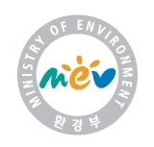
Remarks from Partners…
Government: Ministry of Environment, Republic of Korea
Ms. Inkyu Shin, Deputy Director, Nature Policy Division
Since 2011 when it first joined the Global Partnership for Sustainable Tourism, the Korea Ministry of Environment has had the privilege to interact with the dedicated partners and especially to share with them many great experiences in our journey towards a truly sustainable world. In particular, the Korean Ministry of Environment had the pleasure of taking part in the decision making process of the Partnership as a member of the Steering Committee. The 2nd International Symposium & Annual Conference of Partners held in Seoul, March 12-14 2012, brought together more than 240 participants, including the Minister of Tourism of Madagascar, 6 ambassadors to Korea, representatives from 6 countries, UN agencies (UNEP, UNWTO, UNIDO, UNESCAP), NGOs, businesses and universities, and more than 20 international journalists.
In keeping with the global shift towards sustainable tourism, the Ministry has sought to expand ecotourism where nature conservation and local economic development go hand in hand. In 2010 the Ministry of Environment in collaboration with the Korea National Park Service (KNPS), set out the plan to encourage the existing local communities in the boundary of the National Parks across the country to engage in the Village of Excellence Initiative. The Initiative provides support for improving the living conditions in the human settlements located in the National Park, and guidelines for spreading ecotourism best practices and economic opportunities for local communities.
Ecotourism has given the local communities of the island new business opportunities; eco-lodging, restaurants catering local cuisine and delicacies, and local product and souvenir stores, in line with ecotourism programs focusing on the eye-catching scenery and mind-blowing landscape of the island. As the result, the number of visitors grew sharply from 4,500 in 2010 to more than 500,000 in 2011, enlivening the neighborhood and invigorating the local economy. More and more young persons who moved to city for jobs returned to those communities.
To mainstream ecotourism into policy making at all levels, the Designation Scheme for Ecotourism Destinations was introduced into Korean law in 2013. With the aim of promoting community-based ecotourism development, the scheme has awarded the designation to 17 major destinations to date; and the number is expected to increase, with growing numbers of local communities interested in applying environmental conservation and sustainable use practices to the natural assets they cherish. Among them, 4 destinations were selected for government-backed support, based on their potential to showcase best practices in ecotourism and to encourage other communities to follow suit. These 4 sites include Eco-village in Inje, Yonggye village in Gochang, Village of Excellence in Yeongsando Island, and Seonheul-yil-ri in Jeju Island.
The Korean Ministry of Environment sincerely thanks the Global Partnership and its partners for their commitment and dedication during our collective journey to make tourism more environmentally friendly and sustainable, and hopes to continue its close relationship with the partners, building on the legacy of the Partnership.

NGO: Rainforest Alliance
Ronald Sanabria, Vice President Sustainable Tourism (San Jose, Costa Rica)
Over 12 years ago, Rainforest Alliance began working with tourism businesses, with the goal of improving their environmental performance, while supporting efforts to increase demand for sustainable tourism services and setting global standards for practicing it. Over this period, we have seen the enthusiasm of hoteliers and other industry participants; it is a fact that sustainability efforts have become part of the way many companies do business, but next to it there is also a very clear need to do constant follow-up and due diligence, as well as establishing different categories of assistance, because their needs are different and the solutions must be too.
Precisely, one of the groups we have worked more closely with is small and medium enterprises (SMEs) in Latin America - the vast majority of tourism businesses in this region fall into this category. Undoubtedly, many of the 11,226 people who have participated in our training sessions in tourism sustainability represent that industry segment. With them, our assistance requires a focus on areas such as improving quality and service, health and safety, and setting up adequate pricing structures as determining factors for successful commercialization. Fortunately, their services are well received by the growing number of tour operators committed to sustainability with whom the Rainforest Alliance works to leverage existing commercial channels instead of creating new marketing structures that need to be tested or that are not accessible to SMEs.
It would be irresponsible to promise tourism businesses that if they take on the challenge of implementing sustainable practices, they will automatically get more overnight visitation. However, we can certainly share that there is a growing trend for more responsible tourism and companies have the opportunity today to become part of that paradigm shift.
Latin America already has the proper tools and conditions to facilitate the adoption of sustainable practices, and to maintain and deepen such adoption in the medium and long terms. However, we need to get rid of the tendency to work in isolation. Our experience has shown that we can be more effective if we coordinate individual efforts and focus on the consolidation of sustainable destinations in the countries where we work. We must establish joint commitments if we are to reach a critical mass of sustainable tourism companies in the market.
The challenge many at times lie in the ability to respond promptly and efficiently to the industry´s needs when there is not enough support from tourism ministries, institutes and private sector chambers or associations for sustainable tourism development. It has been challenging to deal with changing governments, with little institutionalization of decisions related to sustainability. To all this, we add the obligation we have to increase consumer access to information to help them make more responsible decisions. We must focus our efforts to do good marketing!
We trust that as the Global Partnership for Sustainable Tourism transitions to the 10YFP Programme on Sustainable Tourism that a platform will grow in Latin America, through which we may develop relationships and also benefit from relationships with other organizations elsewhere, that share the same sustainability commitments.

Private Sector: Roteiros de Charme Hotel Association, Brazil
Building Sustainability into Quality Hospitality
Since its foundation back in 1992, Roteiros de Charme Hotel Association has mainstreamed sustainability of accommodation services as a must to its operation. The Association sees quality of tourism products and sustainability as two equally important dimensions of the hospitality experience that distinguishes a stay in each one of the 65 associated hotels. Spread over 55 tourism destinations in Brazil’s principal biomes, our hotels are committed to perfecting and innovating customer and other services, responding to the expectations of markets in terms of comfort, quality and sustainability. Our hotels also actively encourage staff, service providers, suppliers, as well as neighboring and regional hotels to engage in joint actions aimed at increasing economic, social and environmental benefits, with a view to achieving the much desired sustainability of tourism.
The Association has led the development and implementation of best environmental practices among member hotels, through the adoption of its “Ethics and Environmental Code of Conduct”. This voluntary initiative has promoted the concept of sustainability in the hospitality industry in Brazil and also inspires other segments of the trade. Roteiros de Charme´s Code of Conduct is fully aligned with the latest international standards on tourism sustainability.
All member hotels carry out activities aiming at the spreading of social and environmental sustainability practices at the destinations in which they operate. Over the years, we have learned that the pathway to sustainability relies heavily on the capacity of local stakeholders to innovate and adopt good practices. Construction of networks of cooperation and partnership relations among hotel staff, local suppliers, and key social agents at the destination is a key step towards sustainability.
Partnerships are at the core of the Roteiros de Charme development strategy. From the onset, the Association has looked for partners who share its philosophy of business, environmental and social responsibility. Such partners have been instrumental for the sharing expertise/knowledge, disseminating and in providing financial support for activities. Since 1999, the Association has partnered with the United Nations Environment Programme (UNEP) through its Sustainable Tourism Programme at the Division of Technology, Industry and Economics (DTIE) in Paris.
In recent years, Roteiros de Charme has continued its partnership with UNEP through the Global Partnership for Sustainable Tourism, which has advanced the benefits derived from its sustainability strategy a step further. We acknowledge the highly strategic and intrinsic value to being a member of such a network of trade and global leaders. For the years ahead, our intention is to magnify the involvement of our members in a greater number of strategic partnerships at destinations. As a private sector entity, we wish to scale up the lessons learned and contribute with our acquired knowledge and expertise, the benefits of partnering with other private sector enterprises. Our structure provides a model that allows for multiplier effects within destinations, helping to stimulate sustainable local production and seeking to influence the tourism supply chain.

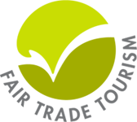
NGO: Fair Trade Tourism
Jennifer Seif, Executive Director, (South Africa)
Fair Trade Tourism (FTT) is Africa’s leading sustainable tourism organisation and a proud founding member of the Global Partnership for Sustainable Tourism (GPST). FTT was established as a project of IUCN-South Africa in 2001 and transitioned to a stand-alone non-profit organisation in 2004. FTT’s activities focus on supporting the private sector to operate in accordance with the principles of sustainable tourism via standards and certification, awareness raising, business development support, advocacy and research. Having established a sound programme of work in South Africa over a decade, FTT’s scope of work now includes a growing number of destinations in southern and East Africa as well as the Indian Ocean Islands. The FTT standard was one of the first to be formally recognized by the Global Sustainable Tourism Council (GSTC) in 2011 and remains the only standard to have achieved GSTC recognition in Sub-Saharan Africa.
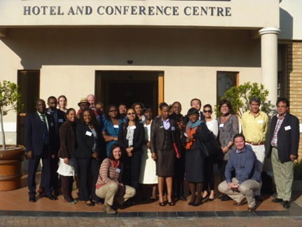
The GPST has afforded FTT a unique platform to engage directly with UN agencies, donors and peer civil society organisations. This platform has resulted in a number of new partnerships, most recently between FTT and GIZ/BMZ. FTT has actively participated in a number of GPST activities including the development of a vital, multi-country project to implement sustainable tourism best practice in southern Africa. In addition FTT in partnership with the GPST Coordinating Office facilitated a technical mission to South Africa in August 2013 to support the Responsible Tourism Directorate of South Africa’s National Department of Tourism. GPST expertise, support and tools have enhanced the enabling environment for tourism planning and development that tangibly benefits people, businesses and the environment.
Sustainable Tourism Certification Alliance Africa
Having attended every annual conference, symposium and meeting since 2011, FTT looks forward to the fifth and final meeting of partners in Windhoek in February 2015. We are fully committed to the implementation of the Programme on Sustainable Tourism of the 10YFP and honoured to be part of the Multi-Stakeholder Advisory Committee (MAC) driving this process. FTT looks forward to ongoing collaboration with the 10YFP to shift travel and tourism to more sustainable forms of consumption and production. The Sustainable Tourism Certification Alliance Africa, of which FTT is the elected Secretariat, will serve as an important mechanism for leveraging opportunities and resources to achieve the goals of the 10YFP Programme on Sustainable Tourism.

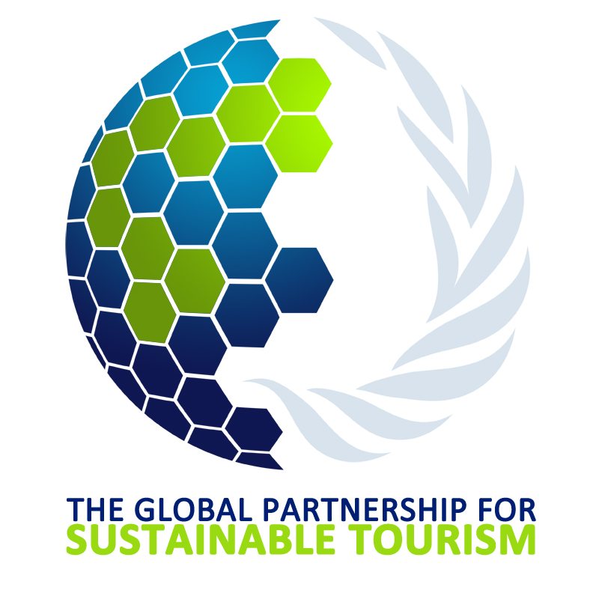
Building Sustainable Tourism Worldwide
c/o United Nations Environment Programme
15 rue de Milan, Cedex 09, 75441 Paris, France
gpstourism.org office@gpstourism.org
Partners…
l’Association des Plus Belles Baies du Monde  Bahamas Ministry of Tourism and Aviation  Brazil Ministry of the Environment  Brazilian Tour Operators Association  Cambodia Ministry of Tourism  Center for Sustainable Tourism, East Carolina University  Centro de Producción Más Limpia  Centro Nacional de Produccion mas Limpia  Cités Unies France  CoaST Cornwall Sustainable Tourism Project  Coastal & Marine Union  Coalition Internationale pour un Tourisme Responsible  Croatia Ministry of Tourism, Department for International Cooperation  ECOTRANS  EMPAASH Oloirienito Conservancy Trust  EthicalTraveler.org  Escuela de ecoturismo, Universidad Andres Bello  Federal University of Pernambuco  French Ministry of Ecology, Sustainable Development and Energy  French Ministère des Affaires étrangères et européennes  Global Sustainable Tourism Council  Grupo GEA – Centre of Eco-efficiency and Social Responsibility  Fair Trade Tourism  German Federal Ministry for Economic Cooperation and Development  Green Action, Let's Do It Nepal!  Instituto EcoBrasil  Institute for Tourism Research of University of Bedfordshire  Institut Français du Tourisme  International Centre for Responsible Tourism  The International Centre for Studies on Tourism Economy of the University of Venice  International Hotel & Restaurant Association  International National Trusts Organisation  International Center for Responsible Tourism of Leeds Beckett University  The Intasave Partnership  The International Institute of Tourism Studies of George Washington University  JLAG  Kenya Tourism Federation  Korean Ministry of Environment  Madagascar Ministry of Tourism  Mali Ministère du Commerce de l'Artisanat et du Tourisme  Ministère du Tourisme du Royaume de Maroc  Mozambique Ministry of Tourism  Norwegian Ministry of Foreign Affairs/Innovation Norway  NECSTouR  Organisation for Economic Cooperation and Development  Organisation Internationale du Tourisme Sociale  Pacific Asia Travel Association  Peninsula Papagayo (Ecodesarollo Papagayo SA)  PLAN BLEU  Puravera S.L.  Regional Tourism Organisation of Southern Africa  Rainforest Alliance  Réseau des Grands Sites de France  Recibase FrSphere - la Francosphere  Roteiros de Charme Hotel Association  Rural Tourism Network  School of Tourism of Bournemouth University  Secretaria de Integración Turística Centroamericana  Social and Environmental Responsibility Centre  Sustainable Travel International  Tesouros de Galicia  Tourisme Montréal  Tour Operators Initiative for Sustainable Tourism Development  The International Ecotourism Society  The Travel Foundation  UNDESA  UNCTAD  UNDP  UNEP  UNEP-GRID ARENDAL  UNESCO  UNIDO  UNWTO  Universitário Dinâmica das Cataratas  Villages Nature  World Travel & Tourism Council

