#NAYDSDGs RWANDA PROGRESS REPORT 2017

Kindly answer the following questions. Kindly give more details when necessary to explain the details. Add additional lines where necessary.

COUNTRY: RWANDA

Country team
Name | Organisation | Position | Email/telephone | Sex
Egide Ntakirutimana | Rwanda Sustainable initiative | Executive Director | newegide@gmail.com/ +250788219611 | M
Imfurayacu Epaphrodite | Rwanda Housing Authority | GIS Officer | Kanoutepa@gmail.com/ +250788766855 | M
Abizera Denyse | One Laptop per Child | Youth Advocate | Abizera.denyze@gmail,com/ +250785227589 | F
Odette Nishimwe | RECOR | Projects Manager | nisette@yahoo.fr/ +250788892522 | F
Mireille Uwera | Musanze District | Land and Settlement Manager | mireillenec@yahoo.fr/ +250788215331 | F
Rutikanga Noel | Kigali City municipality | Master plan implementation officer | runo995@gmail.com/ +250782456823 | M
Emmanuel Havugimana | University of Rwanda | Assistant Lecturer | Emanuel.havugimana@yahoo.co.uk/ +250785438217 | M

- Give a report on the progress and challenges of the country teams since its formation

The team Rwanda started working since February 2015, the team join efforts in conducting campaign to involve youth and their activities in the implementation of SDGs in Rwanda. Mrs Denyse and Mr Emmanuel led a crusade in march 2016 just to advocate that young people are key in implementation of SGDs within higher learning institutions note that in Rwanda Higher learning institution will cover 40% of SDGs implementation, CSOs/NGOs at 30% Government and private sector at 20 and 10% respectively. As a team we also attended the inauguration of SGDs Centre in Africa based in Kigali the team lead presented NAYD work to involve young people in the implementation of SGDs, NAYD activities, goals and mission. A memorandum of understating between NAYD Rwanda and SDG Centre is being discussed.

Egide and Odette with the support from Rwanda Environmental Management Authority led a community awareness campaign on ecosystem restoration toward sustainable development. The role of youth to meet future generation need have been the key point of discussion, environmental protection and sustainable natural resource management is one of success tool to a better future.
Other team members have been involved in SGDs activities both direct and indirectly.

The most important challenges we meet are:
- Organizing meeting periodically because team members are scatted within the country and work in different sectors with require some logistics.
- We don’t have budget to carried out team planned activities we only rely on our organizations budget on only merged activities.
- The team work in informal way meaning it is not registered under Rwanda Governance Board, meaning that we cannot receive any fund from both governments of Rwanda or other funding partners.
- We carry meetings in our respective organization offices with also implicate costs on our working organizations (this bother some people)

- Has the country drafted a country plan? If yes, have you been able to implement any activities? Please give details. Also include pictures.

In Rwanda Country plan we agreed that every quarter we review our plan, most of activities were to make NAYD activities be known mostly by public; private institutions, higher learning institutions, civil societies and development partners. This have been done at 95 percent.

In our plan we also had activities to raise awareness in community health insurance scheme in 4 provinces and Kigali city this activity was funded by ministry of health.

We also run a campaign on clean energy targeting people living in off grid zones to use sustainable clean and renewable energy to light their home and save the environment. The activity was funded by Off grid electric Rwanda.

We led trees planting campaign in Muhanga sector where more than 20000 seeds were planted to protect the catchment of Nyabarongo hydropower plant. This activity was funded with Rwanda sustainable initiative.

We are also doing a vulnerability to climate change assessment with the community living in the vicinity of Akanyaru wetland and come up with community plan in adaptation and mitigation to climate change. This activity is funded by Rwanda sustainable initiative.

- What communication tool are you using to communicate with team members? What communication challenges are you facing? (Especially with team members as well as other youth led organisations). How can it be resolved?

We communicate easily and effectively, we had a chance to have a growing and fastest technology in Africa. So we normally use WhatsApp group, Facebook chart group and emails. Phone calls and sms are used for emergency. We didn’t have a serious challenge in terms of communication as we all get like communication allowances within our respective organization and normally the cost of communication here is fair.

We as team we suggest here that all team member can have nayd emails opened so we can communicate using these emails or we can have country blogs and emails it will be better if we have NAYD Rwanda as part of NAYD international with Rwanda certificate. If we have country website linked to NAYD international, it will be better. www.naydrwanda.org can be also an easy toll to escalate our activities.

- Has the country involved any stakeholders such as UN Agencies, other CSOs/NGOs, other youth led organisations e.t.c in the implementation of activities or for any other reasons
NAYD Rwanda team have a cooperation with:
- SDGs centre
- UNDP
- Albertine Rift Conservation Society
- Rwanda sustainable initiative
- Offgrid Electric
- Mount Kenya University
- University of Rwanda
- Local Government
- Sustaining Rwanda Youth Organization

5. Any other issue/comments/documents/progress

We believe that we are progressing well even if there are some gaps. It is expected that in collaboration with stakeholders all our goals and objectives will be reached in the course of 2017 because many of its initiative we will be running. As a country coordinator, I’m bringing many young people on board to make a strong team from all sectors just to have all SDGs have members working on them.

Photos:

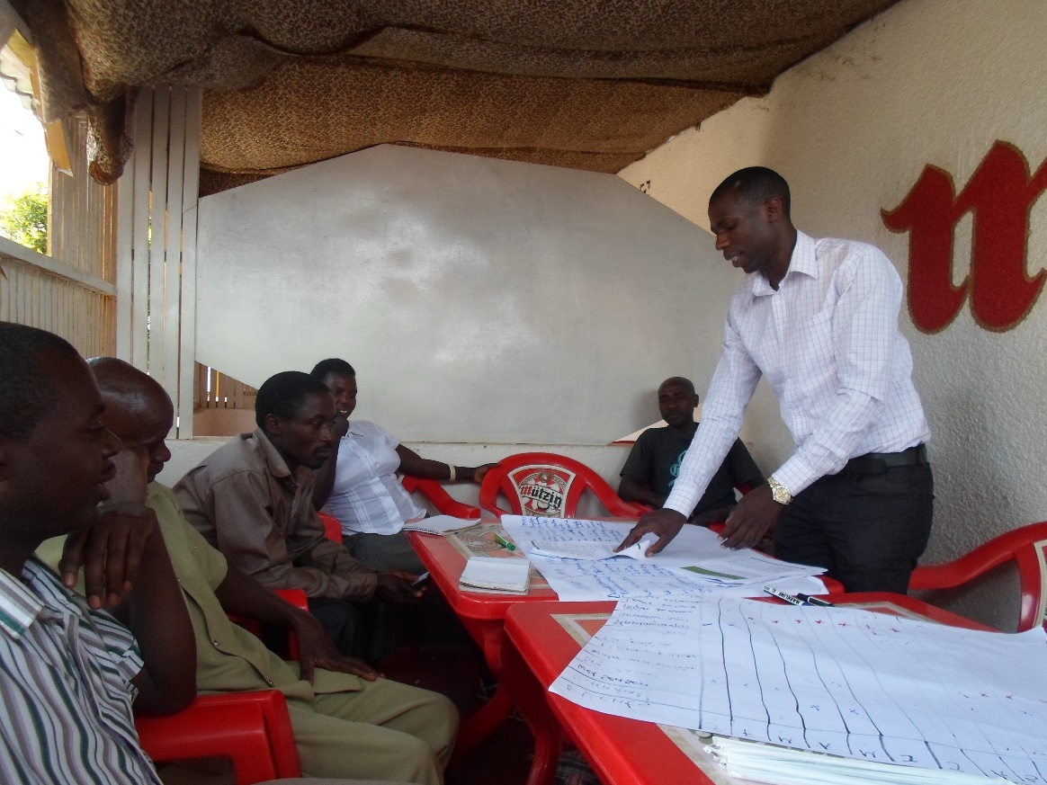
Team During climate change vulnerability assessment
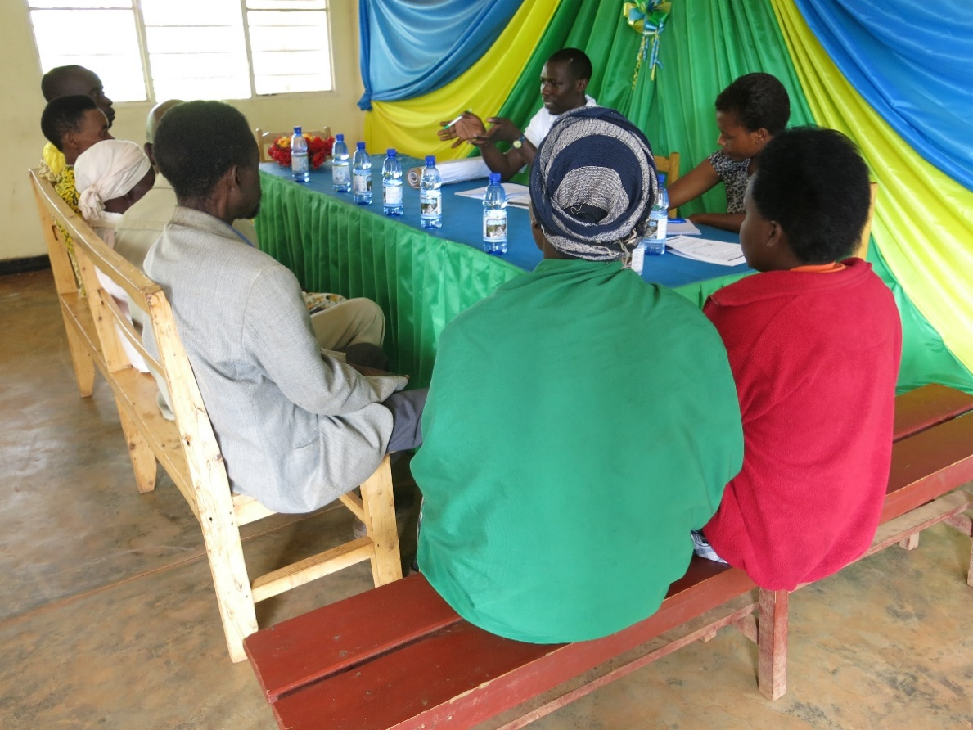
Vulnerability assessment
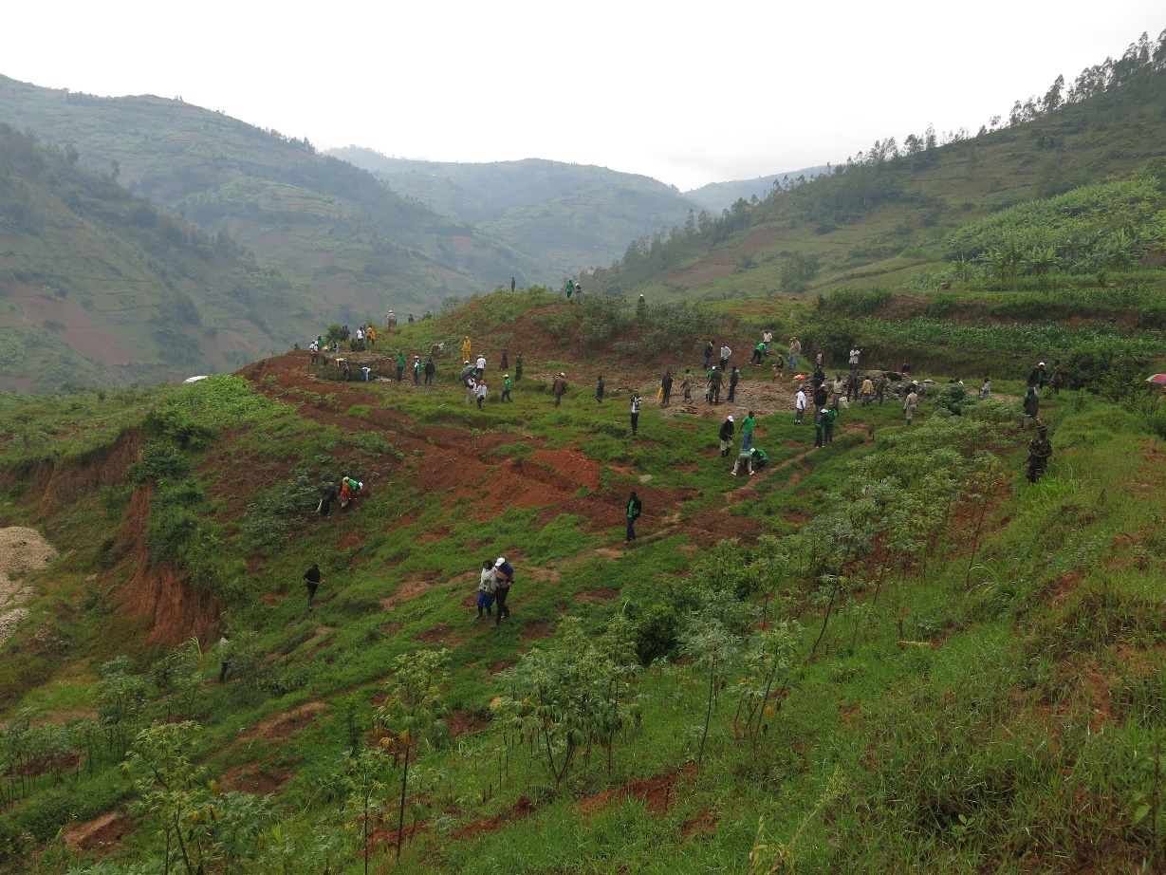
Tree plantation campaign
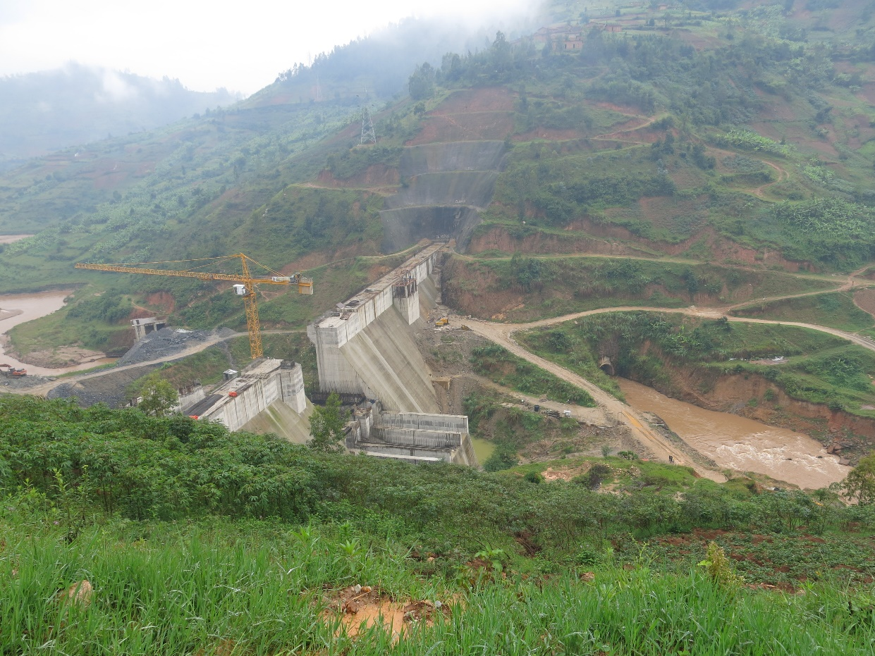
Nyabarongo hydropower plant

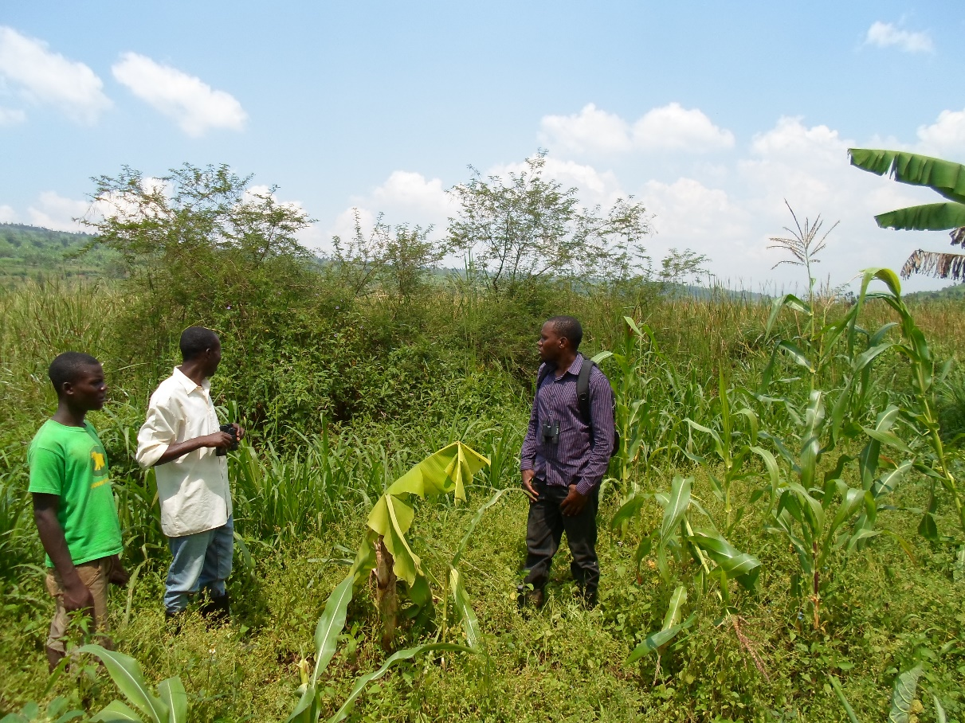

Team in mapping ecosystem services

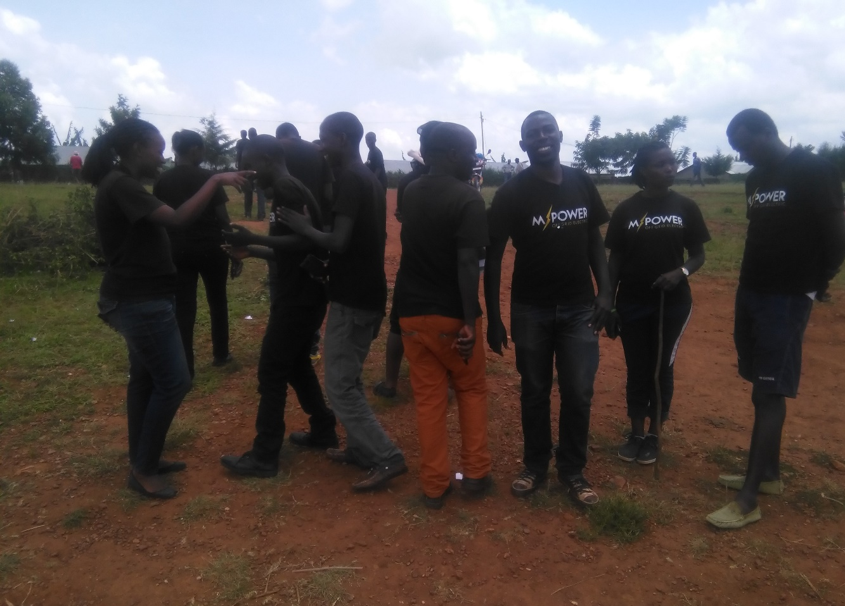

Team in renewable energy mobilization in Rwamagana sector. More than 4000 families started using solar energy after that mobilization.

