#NAYDSDGs PROGRESS REPORT to March 2017

Kindly answer the following questions. Kindly give more details when necessary to explain the details. Add additional lines where necessary.

COUNTRY:

Country team
Name | Organisation | Position | Email/telephone | Sex
Arthur M Kanjere | NAYDSDGs Malawi | Team Leader | _{kanjerearthur@gmail.com}  ₊₂₆₅₉₉₉₄₅₆₅₇₈ | Male

- Give a report on the progress and challenges of the country teams since its formation

There is little progress since formation of Malawi team.

The following reasons contributed to little progress in Malawi:

- Little or no commitment from team members
- Lack of proper guidance and orientation to the first team members
- Few team members
- Little or not participating/contributing during online meetings
- Lack of guidance from Mother board

- Has the country drafted a country plan? If yes, have you been able to implement any activities? Please give details. Also include pictures.

We have had no country work plan

- What communication tool are you using to communicate with team members? What communication challenges are you facing? (Especially with team members as well as other youth led organisations). How can it be resolved?

We communicate through the following channels:
a. Whatsapp
b. Emails
c. Phones

- Has the country involved any stakeholders such as UN Agencies, other CSOs/NGOs, other youth led organisations e.t.c in the implementation of activities or for any other reasons

Some of the country team members were involved in implementation of activities with NGOs because it’s the Organization we work with, and we were involved in the following activities:
1. Civic Engagement to reduce Girls school dropouts
2. Formation and revamping of Rights in Primary
3. Strengthening Capacity of Education structures School Management Committees 4. Parent Teachers Association Area Development Committees and communities in engaging duty bearers
5. Duty bearers are taken to tasks on being transparent an accountable in all developmental activities

- Any other issue/comments/documents/progress
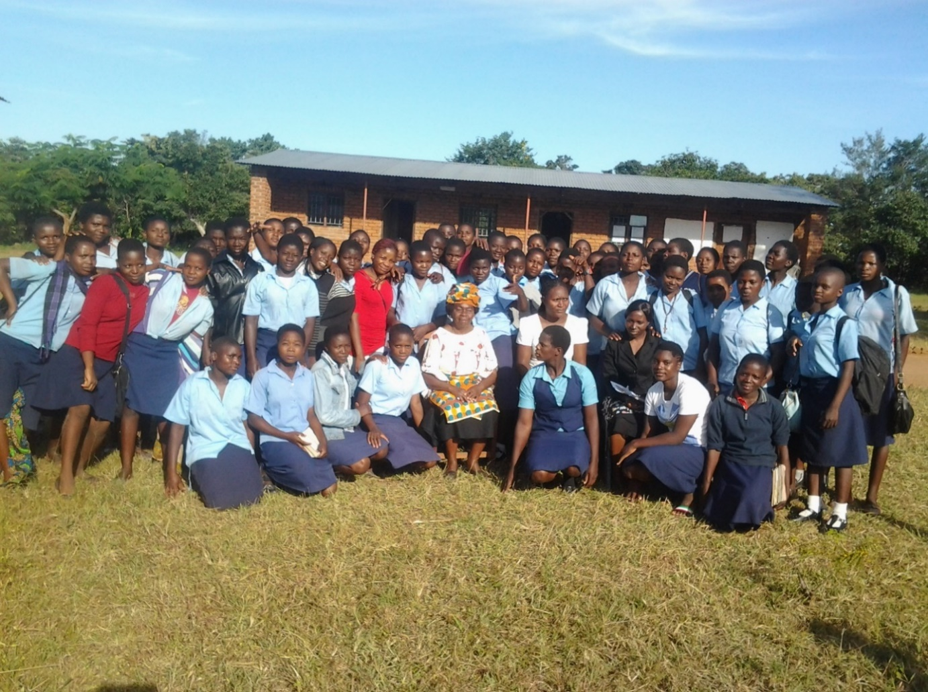 YOUNG WOMEN ARE AT RISK OF CONTRACTING HIV AND AFFECTED BY SRH PROBLEMS?
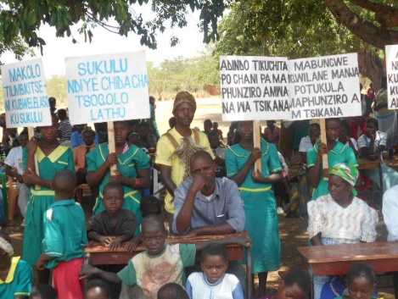
Civic Engagement to reduce Girls school dropouts Open Day 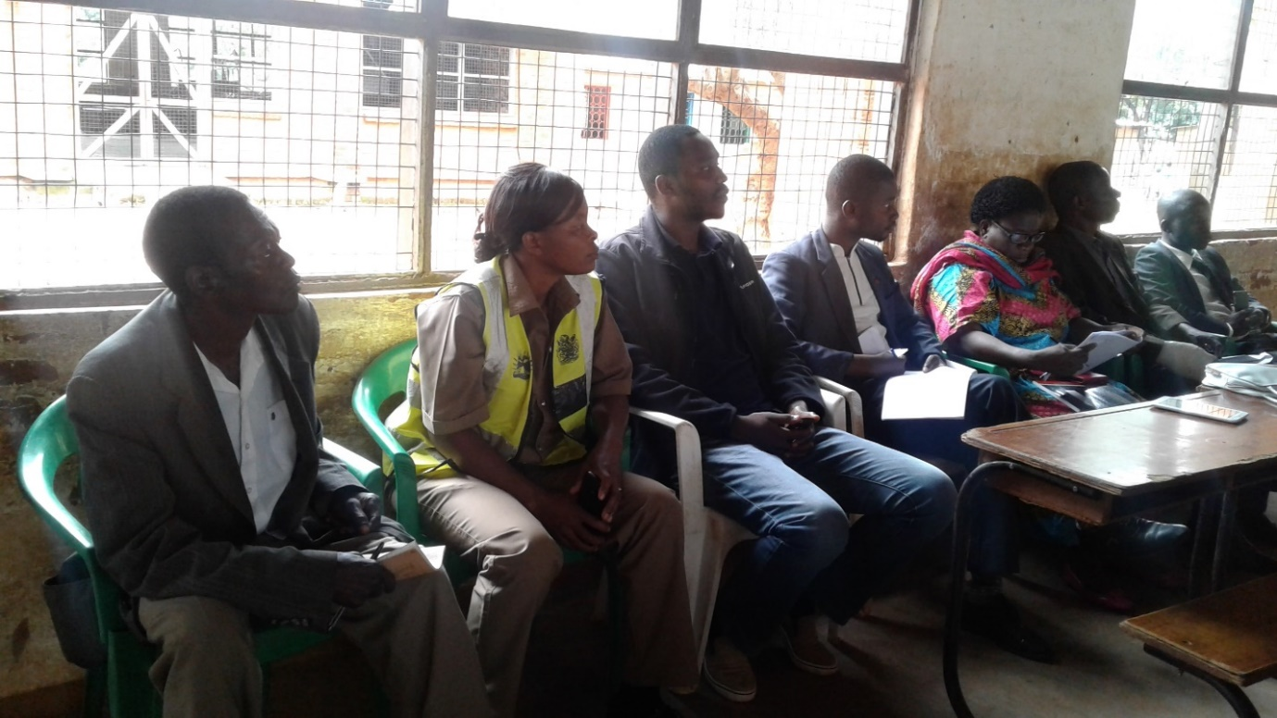
Duty bearers are taken to tasks on being accountable in all developmental activities especially that can hinder Girl childs Education

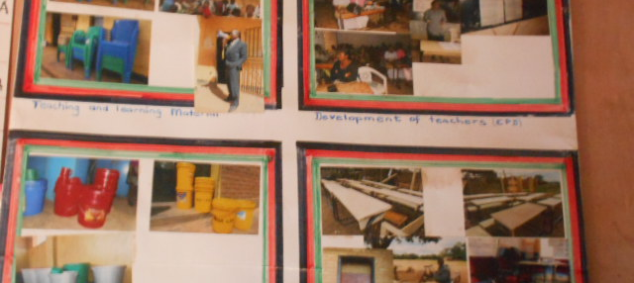
Scholl Heads displaying how the School Improvement Grand
(Transparency and Accountability)

Its my sincerely hope that with the recruitment of the new members and also that of Registered NGOs will help us to be more active and also to have a wide knowledge on how we can get familiarise the SDGs in different angles and also to strength the involvement of women to take part in decision making processes.

